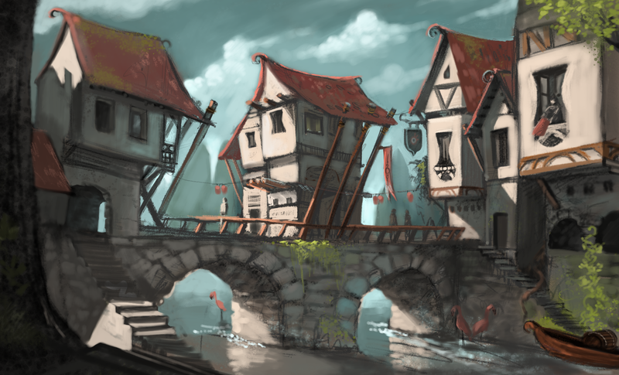
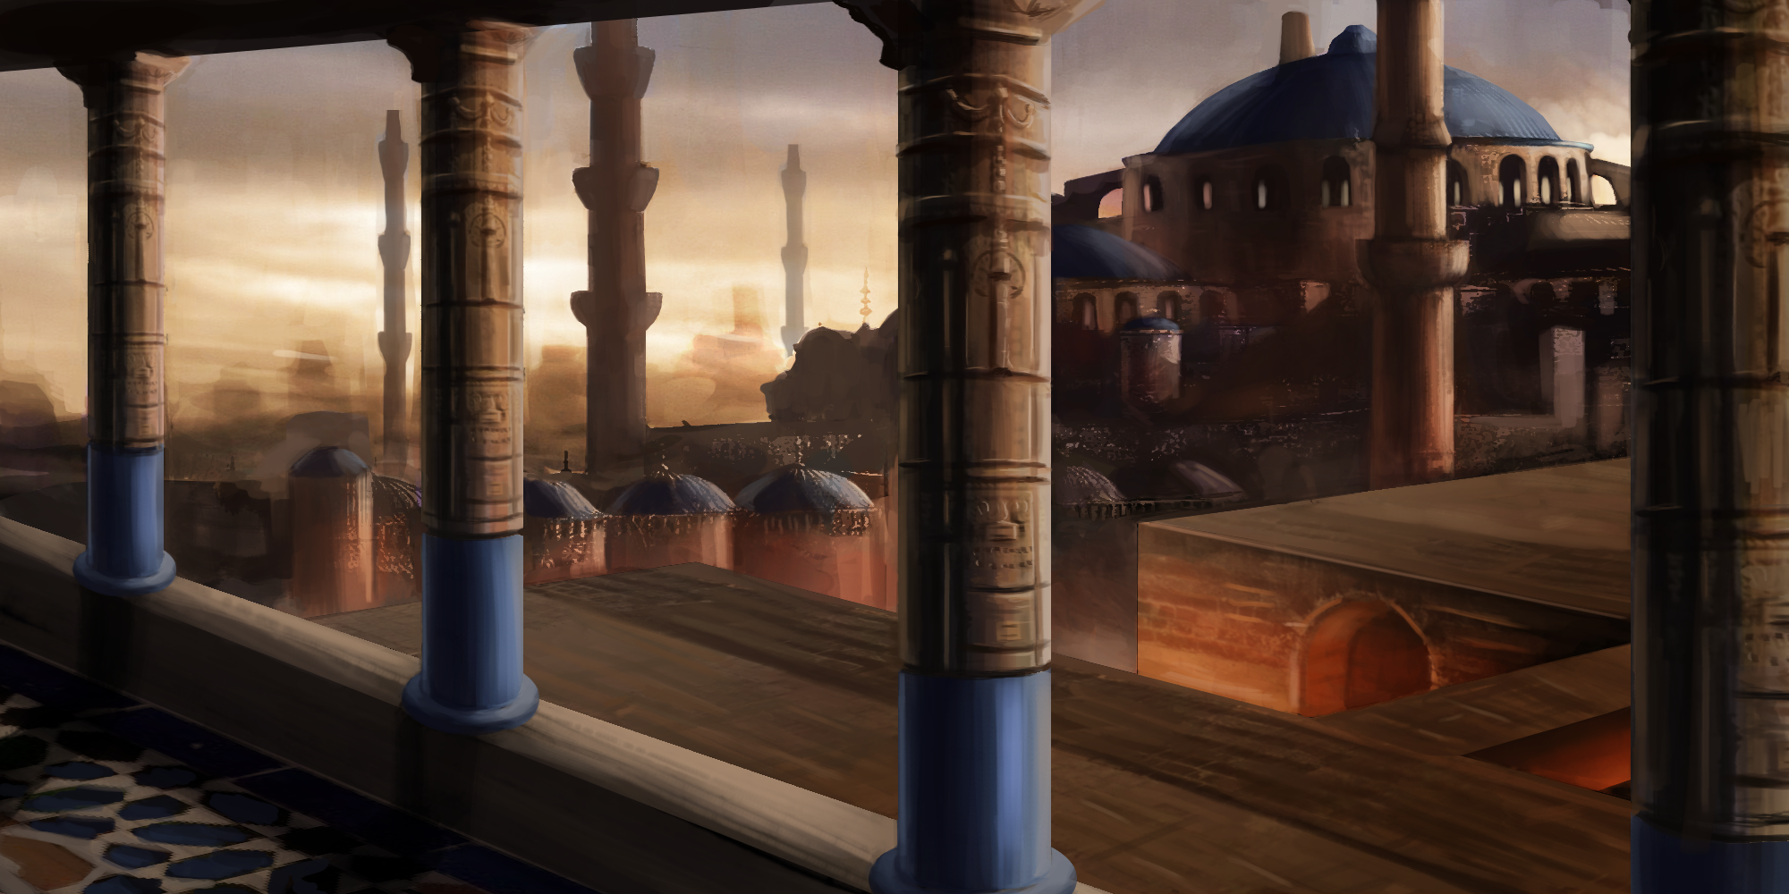
A Byzantine City, One Half as Old as Time
Welcome to Gadding-Thoth, the Twin Cities: the chamber pot and the golden turd; the drunkard embracing the courtesan; the ribald Sun and antique Moon.
Gadding. The Free Port, large and licentious, of the shysters and hucksters, thieves and whores, rats and pigeons. All the world’s peoples pour through its gates and then talk at length about how much better life was in the motherland. It is filthy and vibrant, and in its capacious bay:
Thoth. The Hanging Garden, ancient and storied, of the echoing chambers and pagan temples, treasure hunters and mummified kings, traps and treasures. An age ago its people were so proudful that the gods sank it beneath the waves. A year ago, Gadding’s people were so proudful that they refloated it from the deep.

The Grand Tour
Gadding’s elite are well-familiar with the lore of Thoth and its echoes throughout the world. From the Black Thothites, the seamen who escaped the drowning of Thoth and still lay claim to it, to the Thothic faith, to the ancient arts of writing and fireworks, much is owed to Thoth.
And what better way to celebrate its legacy than to explore it, kill its inhabitants and loot its treasures?

Set Up
Terminology: 1D means the result of one roll of a six-sided die. 2D means the sum of the results of two rolls of a six-sided die.

Districts of Thoth
In its day, Thoth grew ever upward, city block piled on city block, slowly sinking into the muck of the bay before the gods so much as frowned upon it. Exploring Thoth is as often vertical as it is horizontal.
So at first, we create levels of Thoth. This takes several steps. After each step except the last, fold the piece of paper so the next person can’t see what was written before and pass it to the person on your left. Everyone follows these steps at the same time.
- Take a piece of paper and invent the name of a district of Thoth, then write that at the top of the page along with your name.
- Write a few notes on what happened in this district before Thoth sunk. Was it a marketplace, a slum, a religious quarter?
- Write a few notes on what has happened in this district since Thoth was raised. Is it used as a treasure hunter’s camp, a refugee camp, an on-site excavation site, a wizard’s laboratory, an unclaimed wilderness?
- Write a few notes about phenomena found on that level.
- Unfold the map you’ve just received in private and read all the entries. Then draw a district map based on those entries and annotate it heavily. It must include at least one way to get up to a higher level of the city and one way to get down to a lower level.
Once everyone has finished, collect all the maps and put them aside.

Explorers
Here we create the explorers going into Thoth. After each step except the last, fold the piece of paper so the next person can’t see what was written before and pass it to the person on your left. Everyone follows these steps at the same time.
Roll 1D and add it to the number of players. That’s the number of explorers you will create. Divide the cards among the players.
- Write a distinctive feature on a piece of paper.
- Choose a type of armour. Unarmoured (Armour 9), Leather (Armour 10), Chain (Armour 11), Half-plate (Armour 12).
- Write down where the explorer came from.
- Write down three articles of equipment one might bring to a dead city. Flip a coin for each. Heads, keep the equipment. Tails, it’s been lost, broken or used up.
- Write down another three articles of equipment one might bring to a dead city. Flip a coin for each. Heads, keep the equipment. Tails, it’s been lost, broken or used up.
- Roll 2D. That’s the explorer’s hit points.
- Roll 3D. That’s the explorer’s Status.
- Unfold them all. Divide them among the players and let them read them.
- Each player then answers that question or writes another.
Continue doing step 9 until each player has asked or answered a question about every explorer.

First Level
Shuffle the maps and draw the first one. The person who wrote the original name of the district is Game Master for this level.
Distribute the explorers among the other players. You can swap explorers as you like.
The explorer with the highest Status is – at least nominally – the one in command in this trip.

Equipment
Melee weapons do 1D damage. Ranged weapons do 1D-1 damage. A two-handed weapon does +1 damage.
Shield: Ignore one attack, and the shield is broken (repairing is Slow). Ignore an attack with a broken shield, and the shield is shattered beyond repair.

Resolving Difficult Things
If an action is not slow, loud or difficult, do not roll. It succeeds.
If an action is slow and/or loud, but not difficult, roll a doom die (see Doom Dice).
If an action is difficult but not slow or loud, follow the steps below.
If an action is difficult and slow and/or loud, follow the steps below and roll a doom die.

Difficult Actions
- Defend: When you defend yourself or another against a physical attack, roll 3D. If the result is equal to or lower than your Armour, you resist the attack.
- Stunt: When you attempt to do something that requires dexterity, speed or endurance, roll 3D. If the result is equal to or higher than your Armour, you succeed.
- Cunning: When you attempt to do something that requires base cunning, streetwise, cleverness, charm, consorting with low-lives and so on, roll 3D. If the result is equal to or lower than your Status, you succeed.
- Rank: When you attempt to do something that requires manners, book learning, willpower, arrogance, consorting with elites and so on, roll 3D. If the result is equal to or higher than your Status, you succeed.

Failure
What if they fail? Then the GM gets to make a hard move, and also decides whether the action succeeds or not.

Acting and Actions
Who acts first? They go first.
It’s really not difficult. If it’s an ambush, the ambushers go first (unless the ambushees anticipated them). If it’s a stand-off, who’s prepared to break the stand-off? If both parties are surprised, I suppose you could roll stunt to see who recovers faster.
Combat is dynamic, not turn-based. This happens, then that follows logically, then we explore what’s happening in a different corner of the battle, etc. Maybe that means some people get more rolls than others. That’s okay.
How do you manage Slow actions in combat? Each time you attempt a Slow action, roll 1D. On a 6, the action succeeds. You only roll one doom die for attempting a Slow action in combat, and you roll it at the end of the action (whether you succeed or give up).

Doom Dice
Every time the explorers do something loud or slow (or refuse to do anything at all), roll 1D into the middle of the table and leave it there.
If the result matches one of the dice already in the middle of the table, remove both dice: the GM gets to make a hard move.

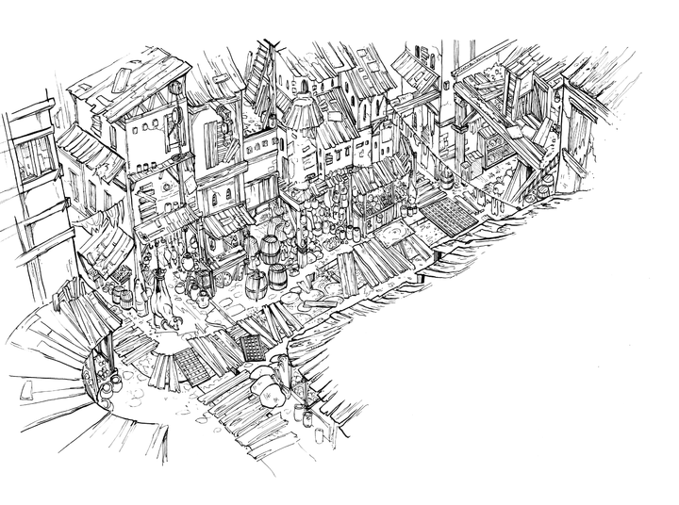
Exploring
Players can try retracing their steps, going back through Thoth, or they can power on ahead. If the GM isn’t at least making a soft move each new room, they’re probably doing something wrong.
Keep drawing on the map. Mostly the GM, but not necessarily:
‘Bartholomew, what do you see when you look through the crack in the door?’ ‘A large feasthall’ ‘Draw it on the map’
‘Bartholomew, what does the spirit’s map contribute to your own?’ ‘Well, they’ve got a lion den’ ‘Draw it on the map’

Going up or down a level
Grab another map. That person is now GM, and figures out where in the new level the party arrives.

GM
This isn’t one of those games where the GM can do whatever he or she wants. The GM can make soft moves whenever he or she likes, and hard moves when the rules allow him or her to. And that’s it.

Soft moves
The GM can do these at any time.
- The Prime Move: Describe the immediate situation and then ask ‘What do you do?’
- Make the world rich: Describe things in detail, make it seem real and fantastic.
- Make a hard move that inevitably follows the fiction: ‘Bartholomew jumps off the cliff’ ‘Bartholomew dies’
- Ask the explorers questions: ‘Bartholomew, where did you learn sorcery?’; ‘Bartholomew, why has your party only encountered women in Mashtapur?’; ‘Bartholomew, can you speak Ancient Thothic?’
- Offer an opportunity with or without cost: ‘She’s offering you a solid gold idol, and all you need to do is betray your friends to get it.’

Responding to Player Requests
If a player wants to do something that is feasible, you have three options:
- Yes: ‘Can Bartholomew climb the wall?’ ‘Yes’
- Yes, if: He or she fulfills some sort of requirement. ‘Can Bartholomew climb the wall?’
  - Making a die roll is the most obvious. ‘Yes, if he can make a stunt’
  - Requiring time, equipment, assistance, knowledge or a compromise are also options. ‘Yes, if he finds climbing gear’; ‘Yes, if he stops halfway up in that dark cave to rest’; ‘Yes, if he can talk Scipis into helping him’; ‘Yes, if he leaves his armour at the bottom’
- Yes, but: There are consequences. ‘Can Bartholomew climb the wall?’ ‘Yes, but the witches will be able to shoot at him while he’s exposed’; ‘Yes, but he’ll be separated from his faithful hound’

Hard moves
A GM can only make GM moves when allowed to do so by the rules.
- Announce future badness: Describe an approaching danger and write it on a card so everyone knows that it’s coming. You don’t need to spell it out. ‘A giant footprint’ is cool.
- Deliver current badness: A future badness that you have already established is now upon us.
- Use a monster move: Monsters have up to three moves. When you get the power to do a hard move, you can do one of these.
- Reveal an unwelcome truth: Tell the players something that they wish wasn’t true.
- Deal damage: A monster attacks them, doing its damage. A rock falls on them, doing 1D damage.
- Use up their resources: Ranged combatants have the Quiver as an abstraction, because tracking arrow by arrow can be boring. This is a good excuse to take away 1 Quiver.
- Turn their action back on them
- Separate them
- Give an opportunity that fits their abilities
- Show a downside to their class, equipment, powers
- Put someone in a spot: Make them make a difficult choice.

More complicated player moves
You can invent them if you like. Here’s the secret: they’re just codifications of the Responding to Player Requests section.
Here’s an example move from Dungeon World:
Ritual: When you draw on a place of power to create a magical effect, tell the GM what you’re trying to achieve. Ritual effects are always possible, but the GM will give you one to four of the following conditions:
- It’s going to take days/weeks/months
- First you must ____
- You’ll need help from ____
- It will require a lot of money
- The best you can do is a lesser version, unreliable and limited
- You and your allies will risk danger from ____
- You’ll have to disenchant ____ to do it
This is just a codification of ‘Yes, if’. ‘Can Bartholomew summon a genie while in this place of power?’ ‘Yes, if he disenchants the vorpal sword and gets help from that cantankerous hermit’.
Or here’s another:
Enchanter: When you have time and safety with a magic item you may ask the GM what it does, the GM will answer you truthfully.
This is ‘Yes’. ‘Can Bartholomew spend a few hours to figure out what this lion figurine does?’ ‘Yes’.

Making Monsters
- Name the monster.
- Being attacked by the monster would be like being hit by:
A punch: The monster does 1D-3 damage.
A kick: The monster does 1D-2 damage.
A longsword: The monster does 1D-1 damage.
A greatsword: The monster does 1D damage.
A bullet: The monster does 1D+1 damage.
A horse’s hooves: The monster does 1D+2 damage.
A car: The monster does 1D+3 damage.
A truck: The monster does 1D+4 damage.
- Eyeball the monster’s Health. 3 to 9 is a normal human range.
- How well protected is the monster? Unarmoured (Armour 9), Leather or hide (Armour 10), Chain or scales (Armour 11), Half-plate or thick plates (Armour 12).
- If the monster has some properties that are always on, add them as Special Qualities.
- Choose some moves that the monster can perform.

Monsters
JADE JUGGERNAUT. Damage 1D+3 • Health 12 • Armour 12
‣ Trample.
‣ Calculate.
BAT. Damage 1D-2 • Health 2 • Armour 9
‣ Fly.
‣ Suck blood.
HALLOWS GHOST. Damage N/A • Health 5 • Armour N/A
SQ: Insubstantial; Flying.
‣ Terrify.
‣ Work through a puppet.
SEA ANEMONE CHILD. Damage 1D-2 • Health 2 • Armour 10
SQ: Immobile.
‣ Paralyse.
‣ Withdraw.
SEA ANEMONE ADULT. Damage 1D • Health 4 • Armour 11
SQ: Immobile.
‣ Paralyse.
‣ Withdraw.
‣ Sprout Sea Anemone Child.
TURQUOISE OOZE. Damage 1D-1 • Health 10 • Armour 14
‣ Absorb.
EYEBALLER. Damage 1D-1 • Health 10 • Armour 12
SQ: Flying.
‣ Gaze of nausea.
IRONBUG. Damage 1D-1 • Health 10 • Armour 14
‣ Shield another.
GIANT SNAKE. Damage 1D+2 • Health 8 • Armour 12
‣ Poison someone.
‣ A poisoned person suffers the effects of the poison.
TUBA TURTLE. Damage 1D • Health 12 • Armour 12
‣ Wall of sound.
‣ Sonic blast.
GNU SORCERER. Damage 1D • Health 6 • Armour 9
‣ Free from bonds.
‣ Cast a force spell.
LOQUACIOUS WORM. Damage 1D • Health 8 • Armour 12
‣ Talk someone’s leg off.
‣ Talk someone into something they don’t want to do.
STROLLING EYE. Damage 1D • Health 6 • Armour 10
‣ Stare someone down.
GIANT WASP. Damage 1D+2 • Health 6 • Armour 11
‣ Sting.

MYNBAT. Damage 1D-1 • Health 2 • Armour 9
‣ Feed off of electricity and mechanical energy.
‣ Display its crystal for its master to look through.
SNAKE CULTIST. Damage 1D • Health 4 • Armour 9
SQ: Immune to poison
‣ Command a snake.
‣ Eat a snake to heal.
‣ Turn into a Giant Snake.
ASSASSIN VINE. Damage 1D • Health 6 • Armour 11
SQ: Plant.
‣ Shoot forth new growth.
‣ Strange the unwary.
CRABFOLK. Damage 1D • Health 8 • Armour 12
‣ Grab a creature in its claws.
‣ Squeeze.
MECHANISED CRABFOLK. Damage 1D+1 • Health 12 • Armour 14
‣ Grab a creature in its claws.
‣ Electrify a trapped creature.
‣ Squeeze.
HELLMAID. Damage 1D • Health 6 • Armour 11
‣ Seize a person.
‣ Fly away with them.
TROLL. Damage 1D+2 • Health 12 • Armour 14
‣ Regenerate.
‣ Disguise self as a stone.
‣ Trample.
VOICE OF TROLLS. Damage 1D+4 • Health 16 • Armour 14
‣ Regenerate.
‣ Speak from the earth.
‣ Grapple.
HARLEQUIN INITIATE. Damage N/A • Health 4 • Armour 10
‣ Change a person’s mind.
‣ Become Harlequin Dervish upon its death.
HARLEQUIN DERVISH. Damage 1D+2 • Health 8 • Armour 11
‣ Glance into crystal ball.
‣ Brandish the red gem of Thoth.
‣ Become Harlequin Revealed upon its death.
HARLEQUIN REVEALED. Damage 1D+4 • Health 16 • Armour 12
‣ Brandish the four red gems of Thoth.
‣ Seize a creature with its tendrils.
‣ Squeeze the life out of a creature in its tendrils.
TOOTHY GEM BEHEMOTH. Damage 1D+4 • Health 16 • Armour 14
‣ Roar.
‣ Store the energy of the earth.

Credits
By Chris Sakkas
First release, 2013.
This work as a whole is released under the Creative Commons Attribution-ShareAlike 3.0 Unported License.
Some text, particularly the GM moves, has been taken from Dungeon World by Adam Koebel and Sage LaTorra where it was released under the Creative Commons Attribution 3.0 Unported License. You must attribute them as well as Chris Sakkas if you share or adapt this work.
Typeset in Linux Biolinium and Linux Libertine. <http://www.linuxlibertine.org/>
The art is from a variety of sources:
- The cover is a crude adaptation of a spectacular piece by David Revoy on Wikimedia Commons and is under a Creative Commons Attribution-ShareAlike Unported 3.0 License. <https://commons.wikimedia.org/wiki/User:Deevad>
  - The bridge that represents Gadding and the marketplace is also by David Revoy and under the same licence.
- The city that represents Thoth is by Justin Nichol and Clint Bellanger from the game Flare on OpenGameArt.org, and is under a Creative Commons Attribution-ShareAlike 3.0 Unported License.
<http://opengameart.org/content/flare-environment-concept-art-pack-1>
- The toothy gem behemoth is by Wyverii on OpenGameArt.org and is under a Creative Commons Attribution 3.0 Unported License.
<http://opengameart.org/content/unsealed-terrex>
- The three harlequins are by Redshrike (aka Stephen Challenger) on OpenGameArt.org and are under a Creative Commons Attribution 3.0 Unported License. <http://opengameart.org/content/3-form-rpg-boss-harlequin-epicycle>
- The two pixel trolls are by Blarumyrran on OpenGameArt.org and are under a CC0 public domain licence. <http://opengameart.org/content/trolls>
- The set of pixel artworks are from a compilation by Redshrike on OpenGameArt.org, and are licensed under the Creative Commons Attribution-ShareAlike 3.0 Unported License. <http://opengameart.org/content/lpc-in-battle-rpg-sprites>
Bottom three sprites: worm, eyeball and bee are all done exclusively by Matthew Nash based on designs by Charles Gabriel.
The Robot (top row, leftmost), the "Blobbert" (Middle row, middle monster) and the enemy anemones (second row from the top) were drawn by Stephen Challenger, based on sprites by Tunicate.
The bat (top row, center monster), ghost (top row rightmost monster), slime (middle row, leftmost monster) and snake (second row from bottom, leftmost monster) were drawn by Stephen Challenger based on sprites by Charles Gabriel.
The Tuba turtle (second row from bottom, middle monster) and the Gnu Mage (second row from bottom rightmost monster) were drawn by Stephen Challenger based on sprites by Ben Potter (Cookiez; http://cookiez999.deviantart.com/).
The beetle was drawn by Stephen Challenger based on a sprite by Stephen Challenger.

